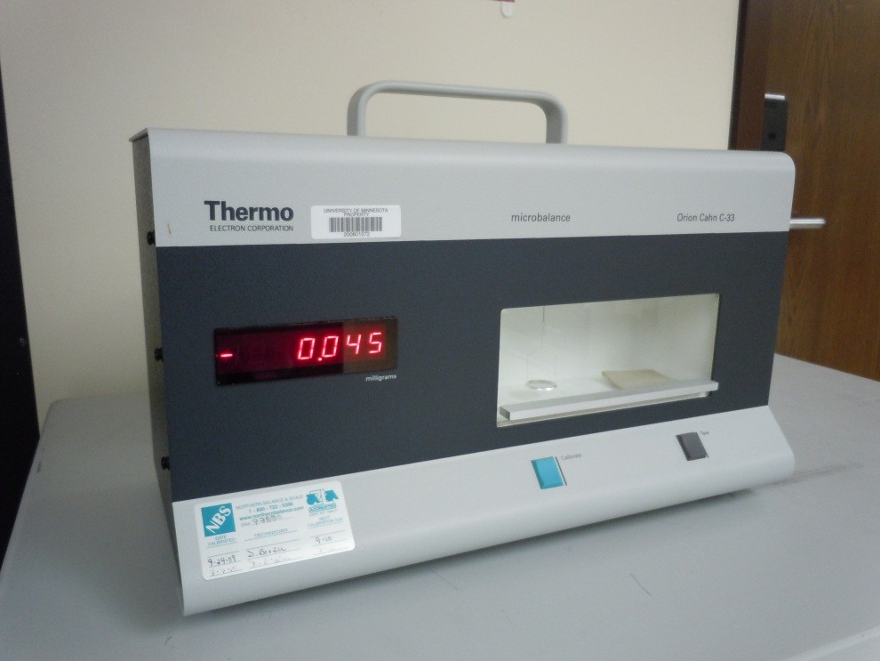
Instrument
Microbalance

Model / Number
Cahn C-33

Manufacturer
Orion supplied by Thermo
Electron Corporation

Location
Life Science 250

Instrument Description
Single pan microbalance. The balance is very stable, does not require temperature controlled environment and is situated on a balance table work station. Specifications: Capacity 250mg; Precision 1µg; Weigh range 200mg; Readability 1µg; Reproducibility 1µg; Linearity 1µg; Response time 10 seconds; Tare Range 250mg; Pan size up to 60mm; Output RS232. Calibration weight, gloves, and tweezers on work station.

User Charges
Not applicable

User Information
User must have key card access to Life Science 250. User must be trained to use this equipment. The user is responsible for cleaning and performing any per use maintenance and providing any disposable supplies required for operation. Any damage caused by the user is the responsibility of the user to repair or replace.

