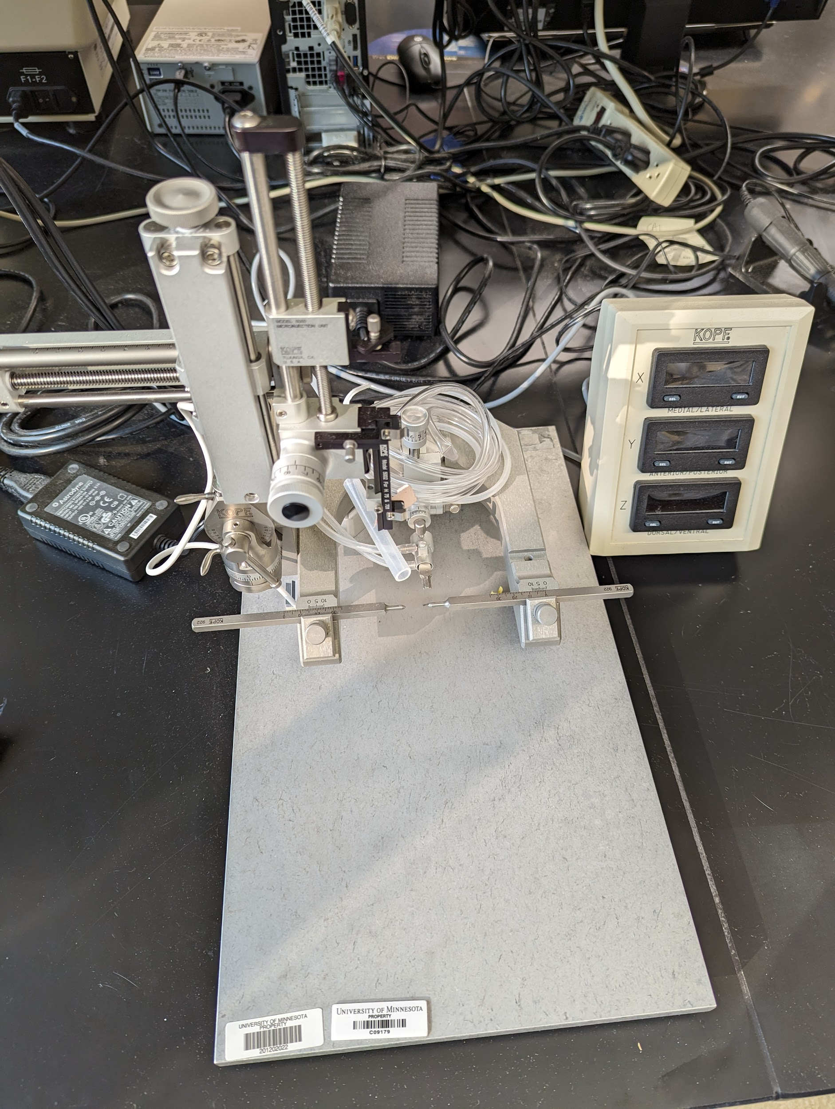
Instrument
Stereotaxic Instrument
Model / Number
940-A
Manufacturer
Kopf Instruments
Location
Life Sciences 250
Instrument Description
Small animal stereotaxic instrument with a digital display console for state-of-the-art linear positioning for full range of motion, angulation and rotation. Linear scale has a 10 micron resolution.
User Charges
Not applicable
User Information
User must be trained to use this equipment prior to use and are responsible for all consumables needed like O2 and Isoflurane. Any damage caused by the user is the responsibility of the user to repair or replace.

