Instrument
Shaking Water Bath

Model / Number
4645

Manufacturer
Lab-Line

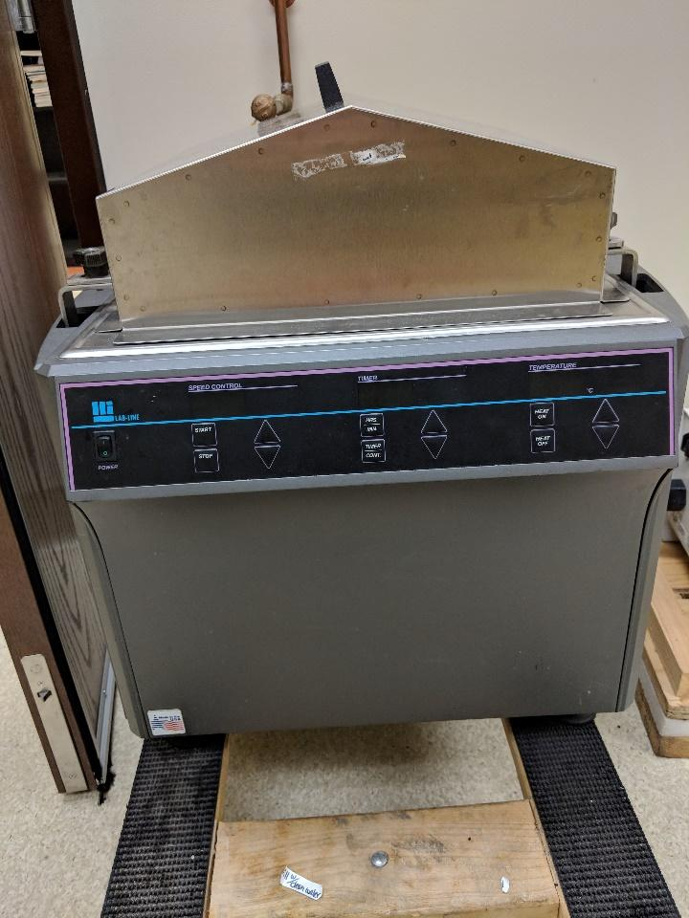
Location
Life Sciences 250E

Instrument Description
Single-piece stainless steel orbital shaker with speeds ranging from 15-500 rpms and heating up to 100C.

User Charges
Not applicable

User Information
User must be trained to use this equipment prior to use. Any damage caused by the user is the responsibility of the user to repair or replace.

