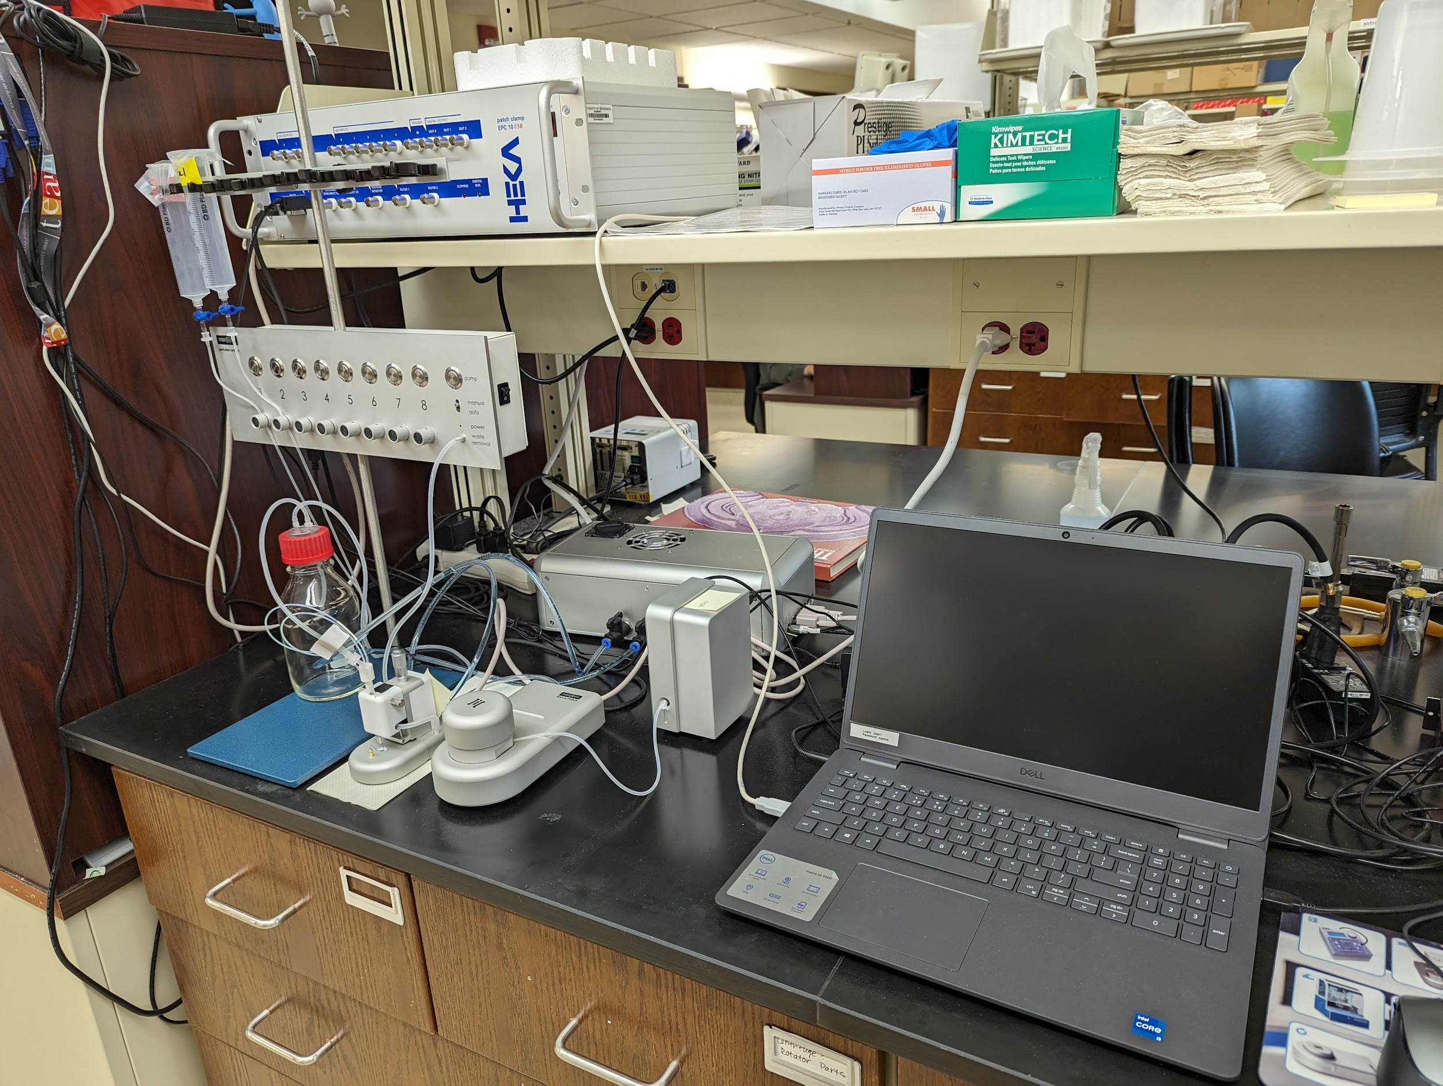
Instrument
Port-a-Patch System
Model / Number
Manufacturer
Nanion
Location
Life Sciences 250
Instrument Description
User Charges
Not applicable
User Information
User must be trained to use this equipment prior to use. User is also responsible for their own consumables including chips. Any damage caused by the user is the responsibility of the user to repair or replace.

