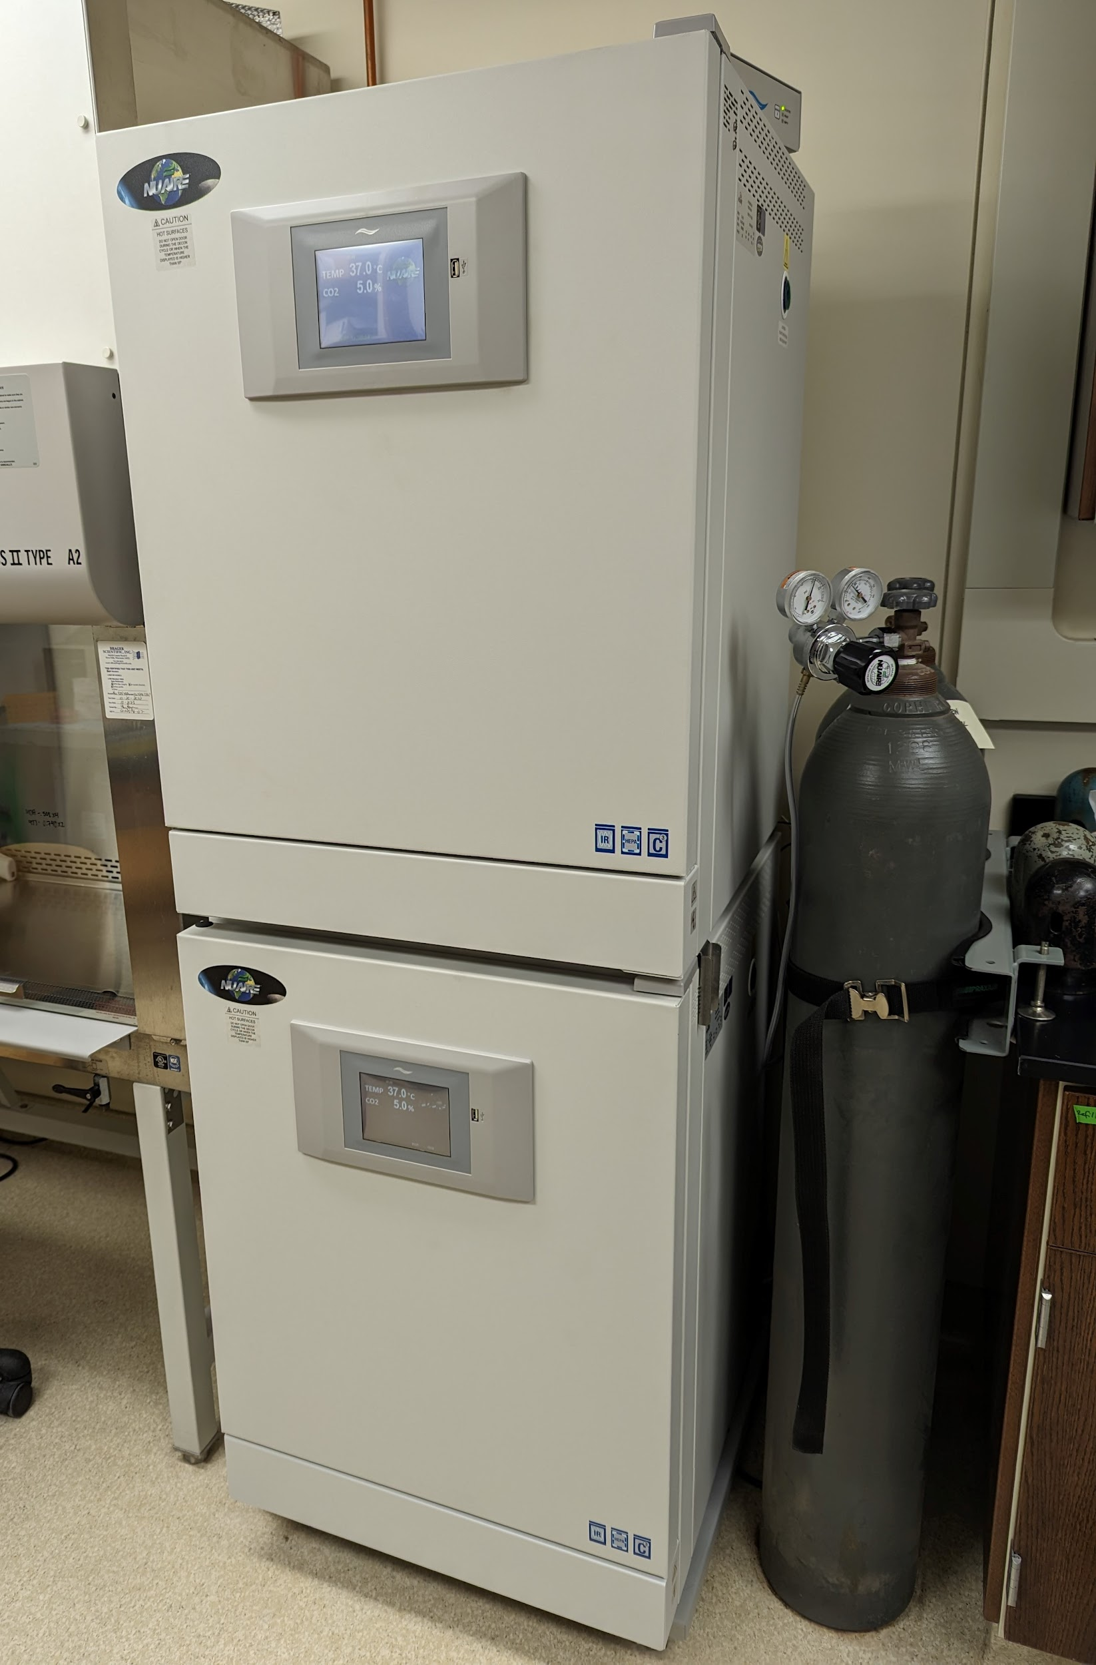
Instrument
CO2 Incubator
Model / Number
NU-5710
Manufacturer
NuAire
Location
Life Sciences 250E
Instrument Description
NuAire direct heat incubators have built-in decontamination cycles, precise temperature and CO2 controls with electronic interface for user-friendly programming. These incubators have a large 5.7 cu.ft. interior chamber size directly heated with attached elements and a closed-loop air circulation system.
User Charges
Not applicable
User Information
User must obtain permission from Laboratory PI to use these incubators. Any damage caused by the user is the responsibility of the user to repair or replace.

