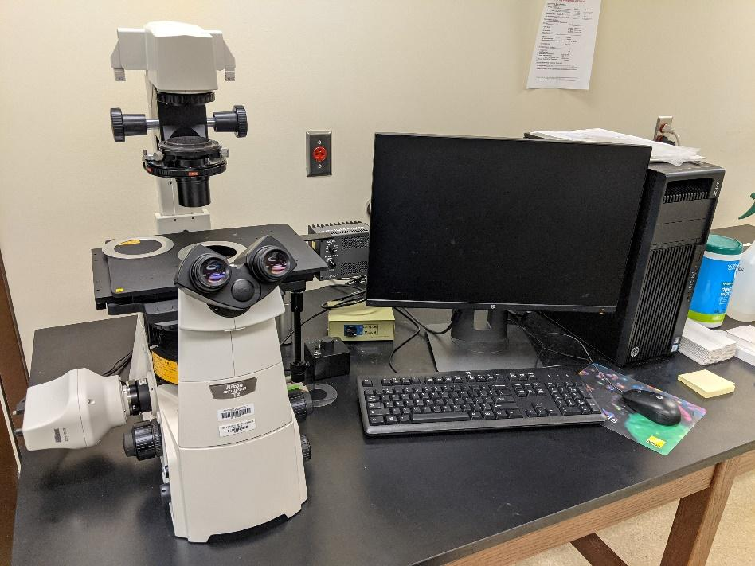
Instrument
Inverted Fluorescence Microscope

Model / Number
Eclipse Ti-S

Manufacturer
Nikon

Location
Life Sciences 250B

Instrument Description
This microscope is fit with 4x to 40x objectives for brightfield, fluorescence or phase contrast images. Sample plates allow for imaging slides and culture dishes. The connected computer has the Nikon Elements software allowing for both live and capture imaging modes along with analysis options.
User Charges
Not applicable
User Information
User must be trained to use this equipment prior to use. Any damage caused by the user is the responsibility of the user to repair or replace.

