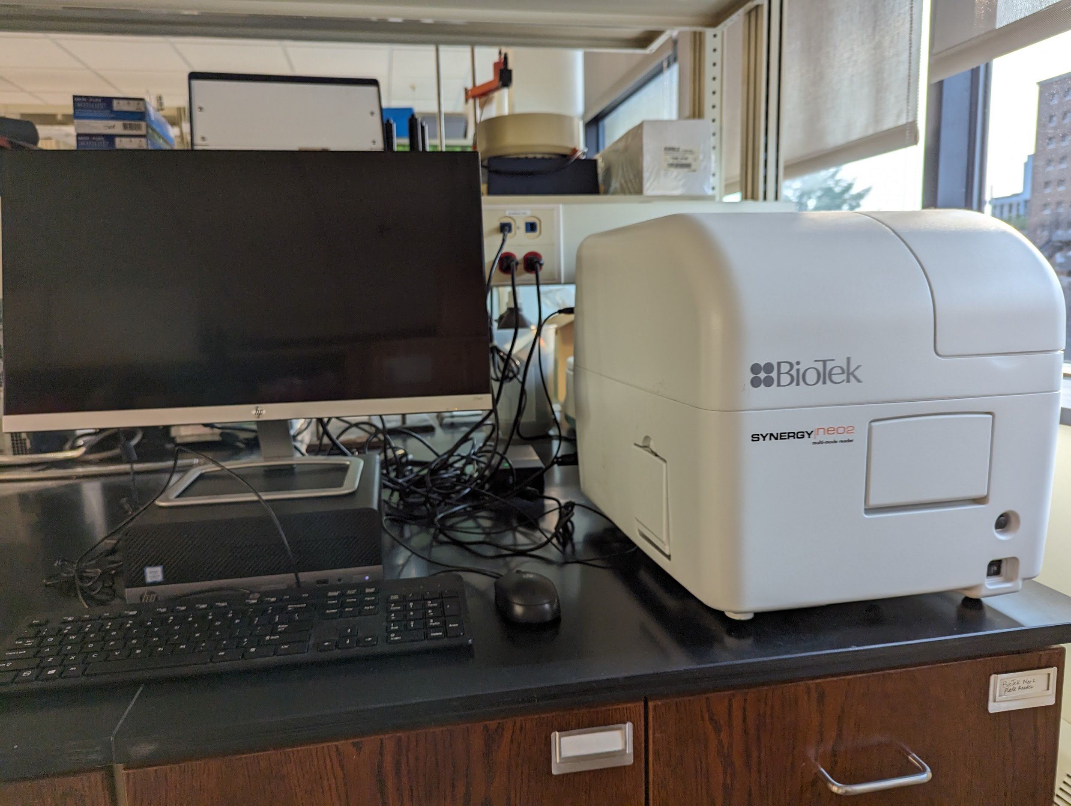
Instrument
Plate Reader
Model / Number
Synergy Neo 2
Manufacturer
BioTek
Location
Life Sciences 250
Instrument Description
A multimode microplate reader with variable bandwidth monochromaters, filter based optics, time resolved fluorescence capabilities and PMTs all allowing for ultrafast measurements.
User Charges
Not applicable
User Information
User must be trained on this equipment prior to use. Academic Health Center login credentials are needed to use this equipment. Any damage caused by the user is the responsibility of the user to repair or replace.

