Instrument
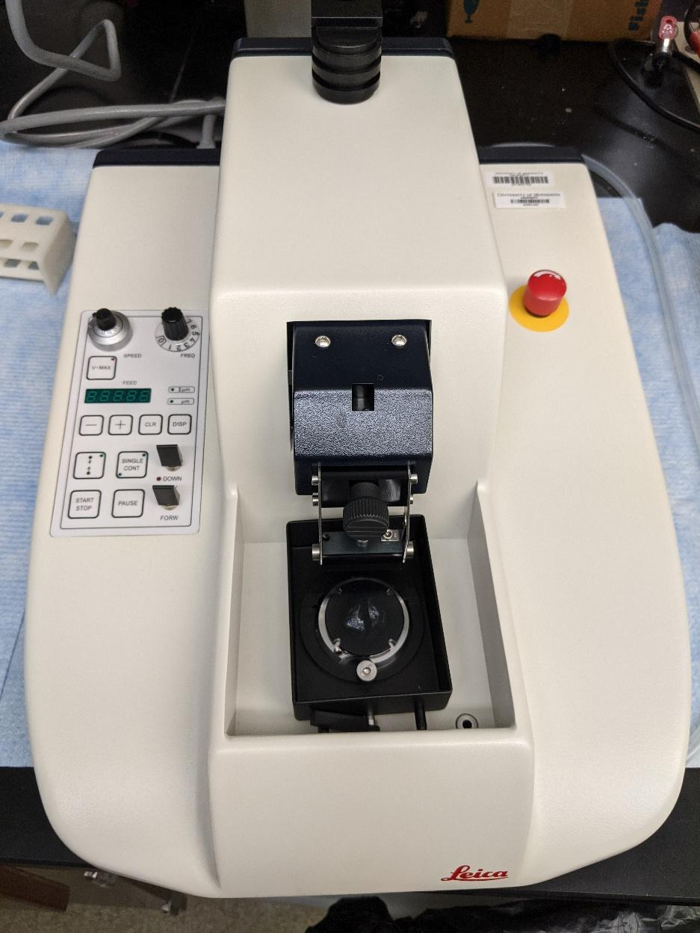
Vibratome

Model / Number
VT1000 S

Manufacturer
Leica

Location
Life Sciences 250

Instrument Description
For sectioning fixed tissues, has adjustable frequency and amplitude, fully automated cut mode, adjustable knife speed.

User Charges
Not applicable

User Information
Users must be trained to use this equipment prior to use. User is responsible for own consumables used with the equipment. Any damages caused during use which require repair/replacement will be the responsibility of the user.

