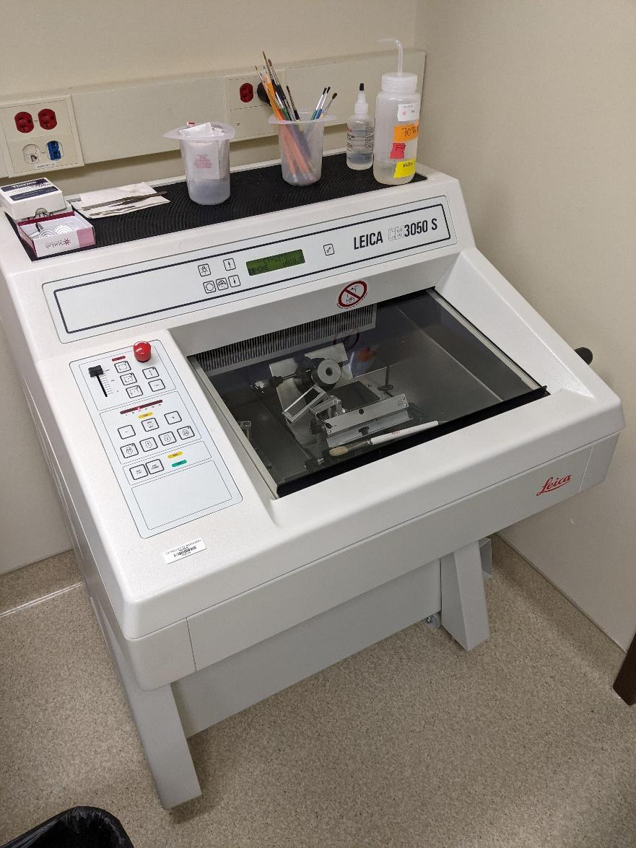
Instrument
Cryostat

Model / Number
CM3050 S

Manufacturer
Leica
Location
Life Sciences 250C

Instrument Description
Precisely cuts frozen fresh tissues or Drosophila at various depths, mounting head is adjustable in both x and y planes, chamber maintains -20C temperature, both pedal drive and hand crank capabilities.

User Charges
Not applicable

User Information
Users must be trained to use this equipment prior to use. User is responsible for own consumables used with the cryostat. Any damages caused during use which require repair/replacement will be the responsibility of the user.

