Instrument
Overhead stirrer used for tissue homogenization

Model / Number
RZR 2052

Manufacturer
Heidolph

Location
Life Sciences 250

Instrument Description
A reliable, variable speed mixer with stepless speed control. Glass mortar and plastic pestle available to use upon request.

User Charges
Not applicable
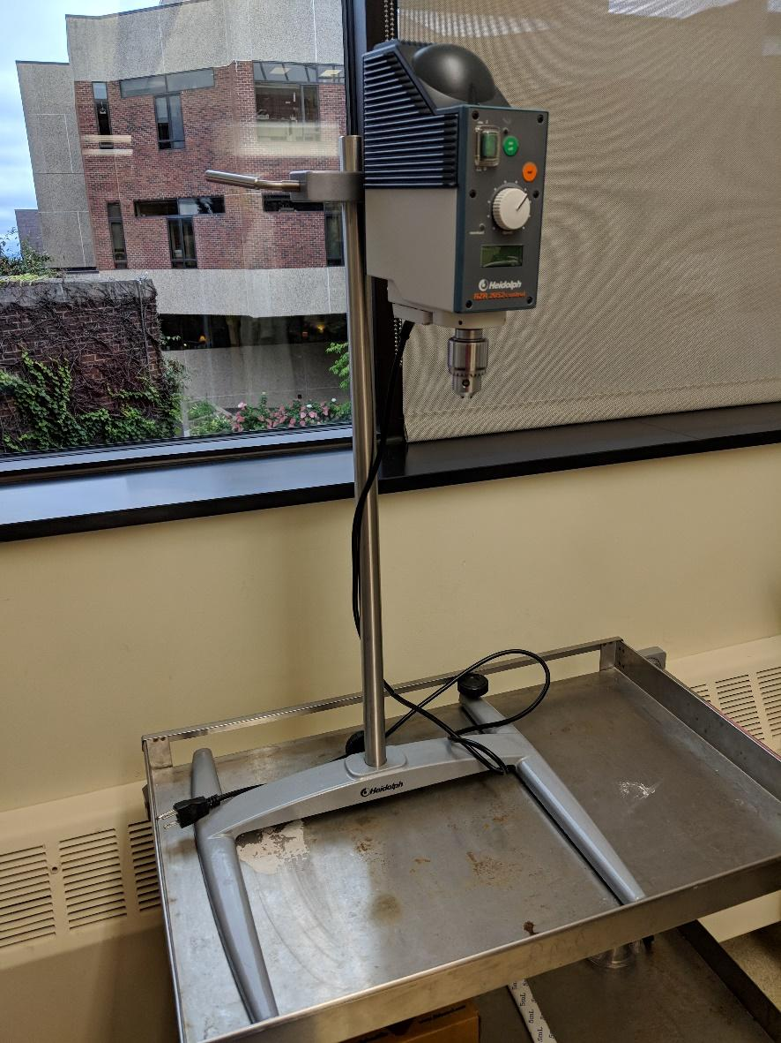

User Information
User must be trained to use this equipment prior to use. Any damage caused by the user is the responsibility of the user to repair or replace.

