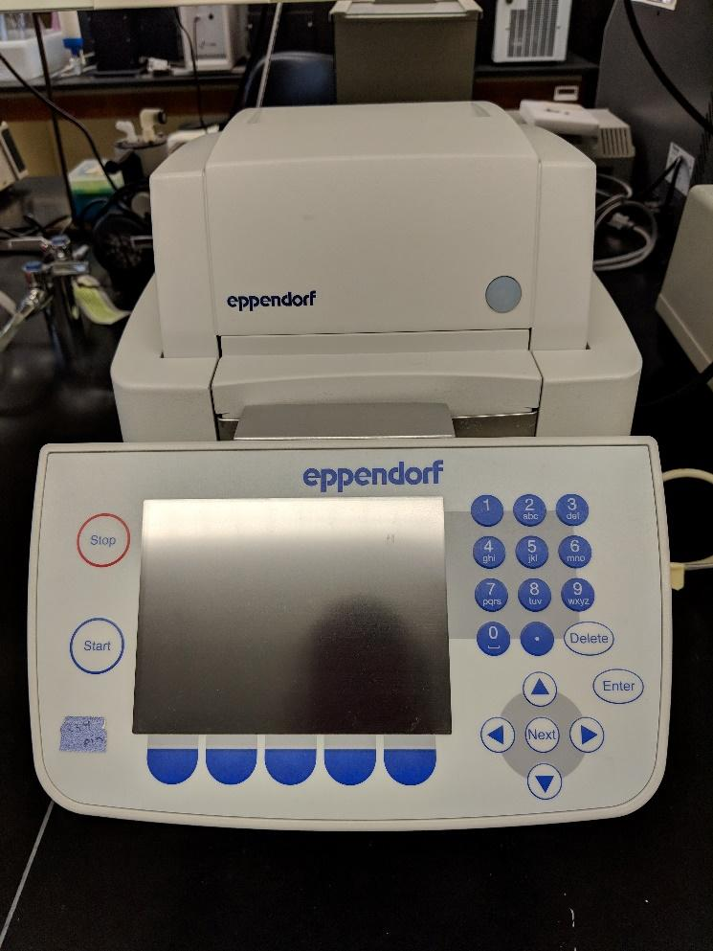
Instrument
Thermal Cycler

Model / Number
Mastercycler EP

Manufacturer
Eppendorf

Location
Life Sciences 250

Instrument Description
This gradient thermal cycler rapidly heats and cools for optimal PCR conditioning. Its electronic control panel allows for user sign in and an easy-to-use graphical interface.

User Charges
Not Applicable

User Information
User must be trained to use this equipment prior to use. Any damage caused by the user is the responsibility of the user to repair or replace.

