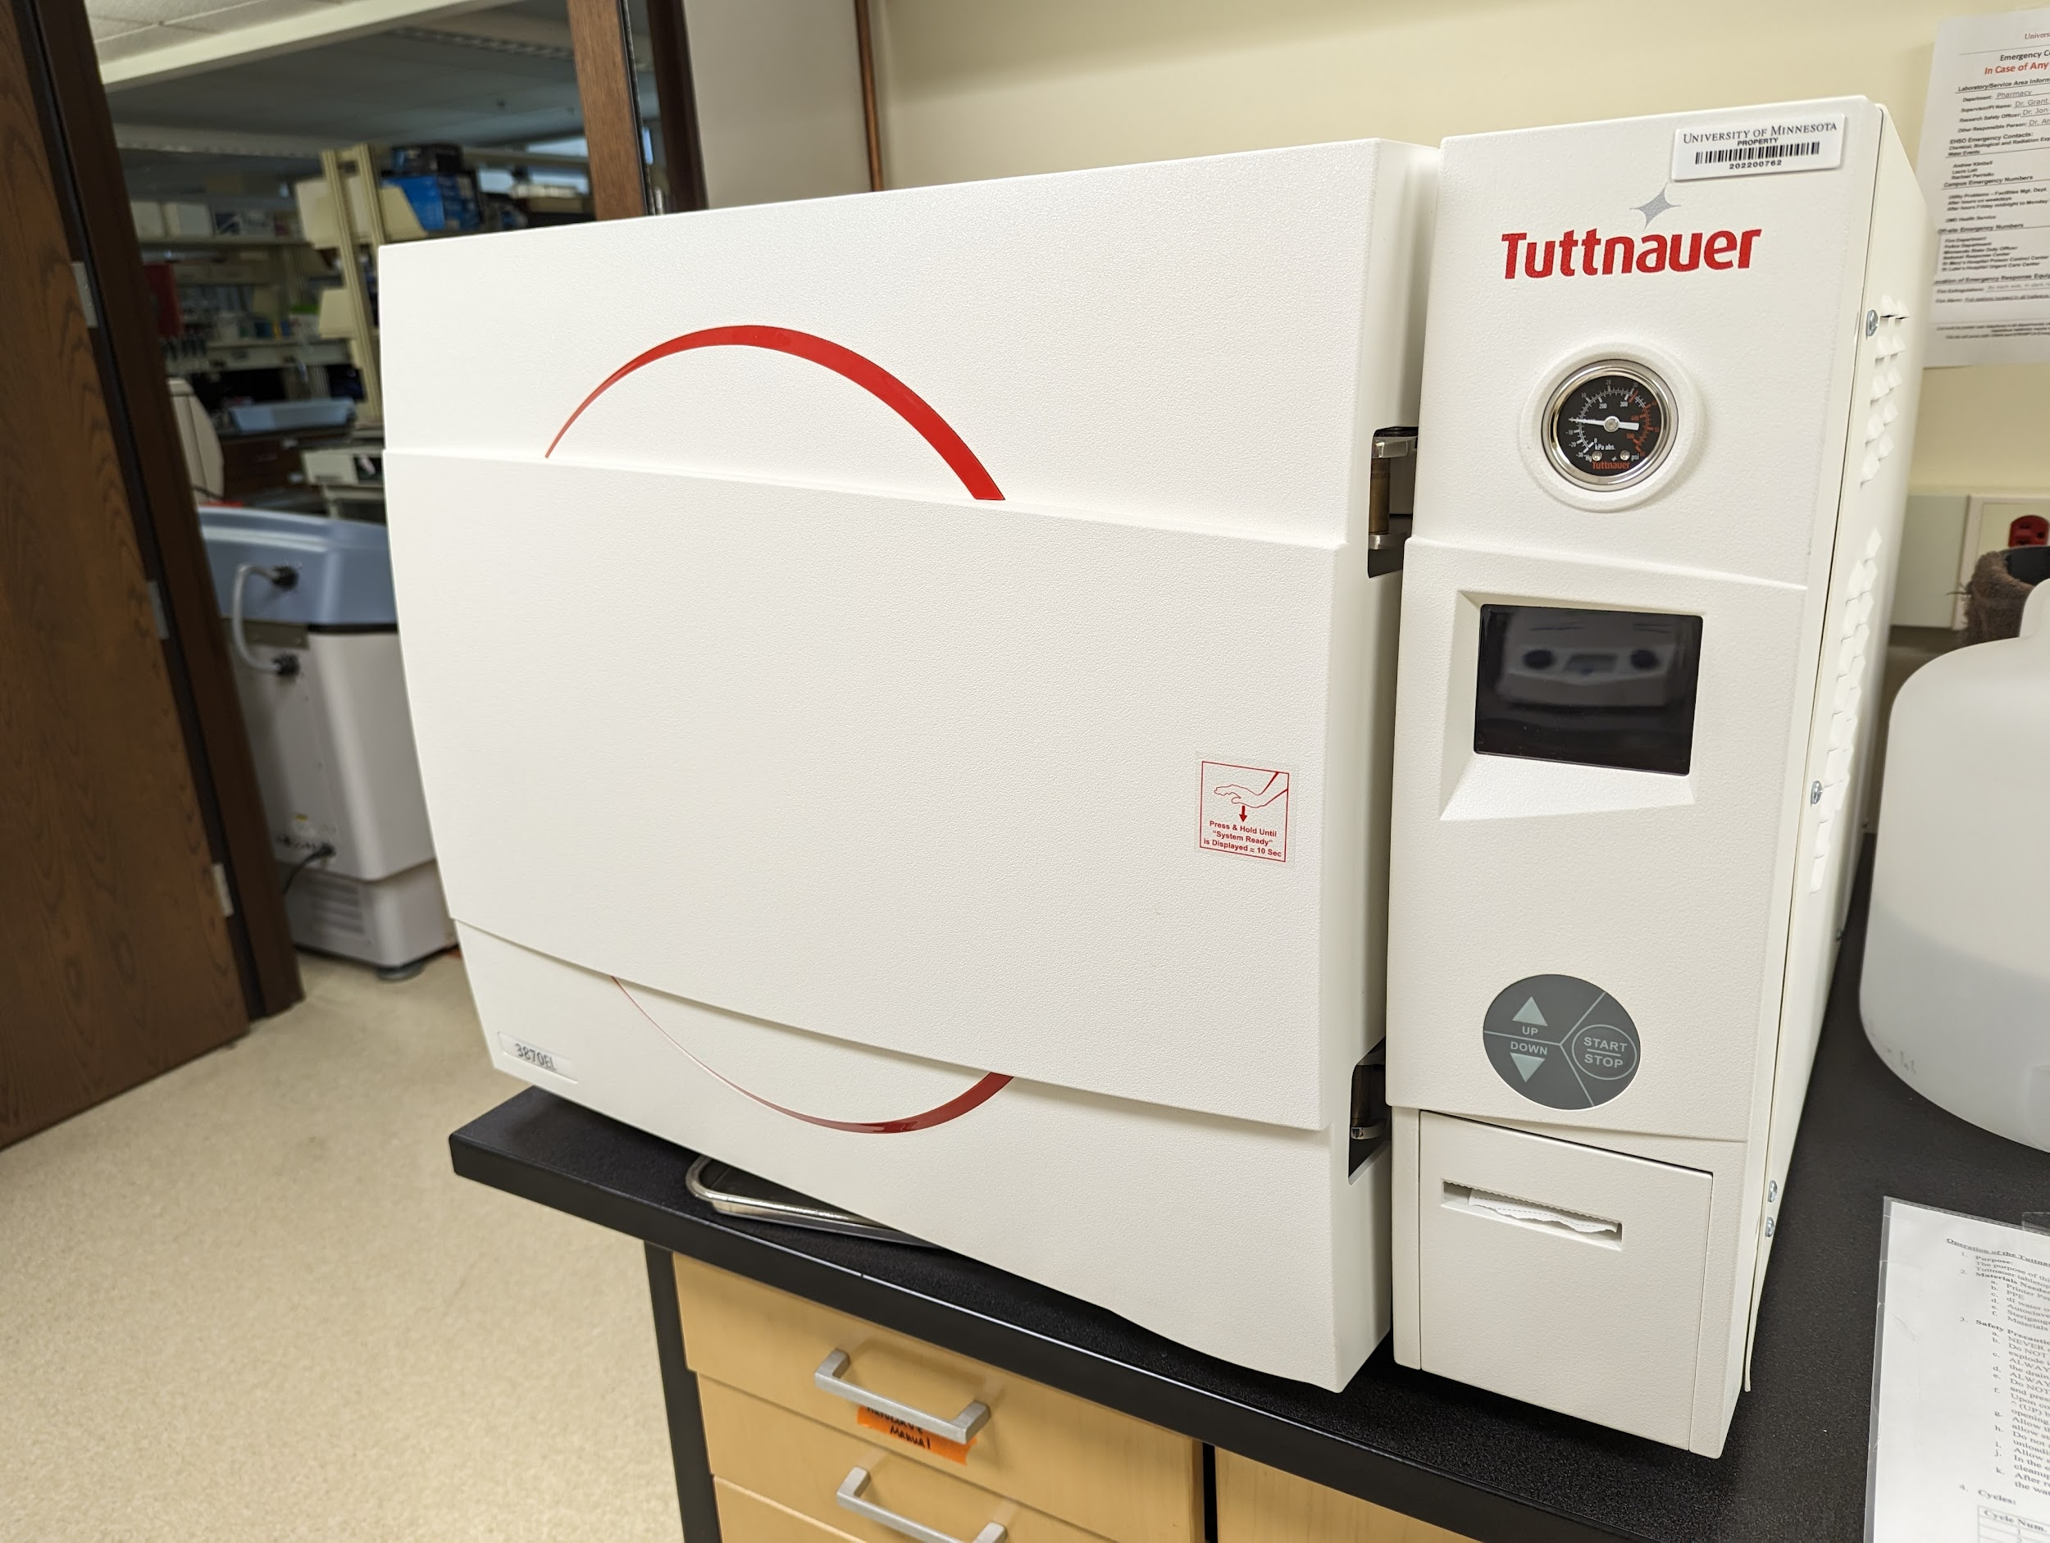
Instrument
Autoclave

Model / Number
3870EL

Manufacturer
Tuttnauer

Location
Life Science 250C

Instrument Description
Preprogrammed with 5 cycles to sterilize glass, surgical instruments, liquids and biohazardous waste.
User Charges
Not applicable

User Information
User must be trained to use this equipment prior to use. Any damage caused by the user is the responsibility of the user to repair or replace.

