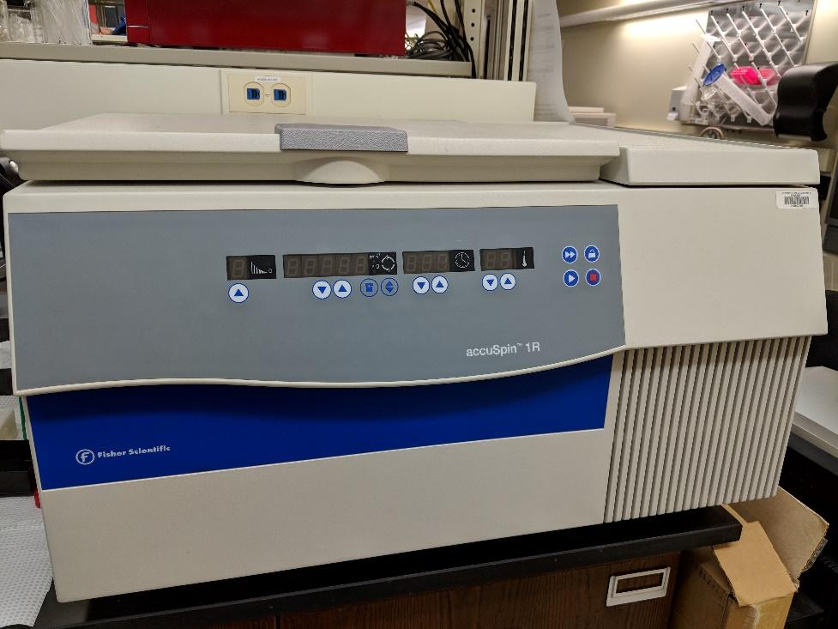
Instrument
Low speed centrifuge

Model / Number
accuSpin 1R

Manufacturer
Fisher Scientific

Location
Life Sciences 250

Instrument Description
The general-purpose tabletop centrifuge is designed to separate liquid suspended materials having different densities and particle size, respectively.

User Charges
Not Applicable

User Information
User must be trained to use this equipment prior to use. Any damage caused by the user is the responsibility of the user to repair or replace.

